New Clues for Chemotherapy-Induced Cognitive Impairment
Posted by Nousha Khosh on Thu, Feb 28, 2013

Cancer is the formation of a malignant neoplasm, initiated by a cell that escaped apoptosis upon which mutations during DNA replication were not repaired; this cell, no longer regulated, continuously proliferates while each progeny will carry the previous mutation(s), while generating new ones, eventually resulting in a population of unregulated cells (malignant tumors) that will metastasize and take over the host’s body. Thus, the conventional cancer treatment consists of surgical resection of the tumor mass, followed by administration of agents which kill any diving (mitotic) cells in the body (chemotherapy and radiation therapy). Consequently, these agents will not only target proliferating cancer cells, but they also destroy healthy proliferating cells, hence the side effects associated with chemotherapy, such as hair loss, nausea and cognitive deficits. This article emphasizes on chemotherapy’s role in disrupting processing speed, working memory and attention in humans.
Adult neurogenesis is the post-natal process of generating functional neurons (and glial cells) from adult neural precursors/progenitor cells (NPCs) throughout life. The two regions in the adult brain in which neurogenesis occurs are the subventricular zone (SVZ) of the lateral ventricle and the subgranular zone (SGZ) of the dentate gyrus (DG) in the hippocampus. Newly generated cells in the SGZ can differentiate into functional neurons and integrate into the adult hippocampus’s DG as granule cells. Granule cells are involved in memory formation and many aspects of learning, with the exception of long-term memory storage.
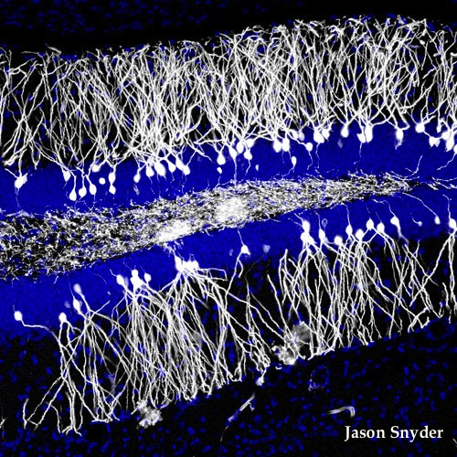
Over 50% of cancer patients undergoing chemotherapy report significant cognitive impairment and declines in their overall cognitive processing, collectively referred to as “chemo-brain”. Thus, chemotherapy-induced loss of newly generated neurons in the hippocampus and impeding adult neurogenesis as the cause of such cognitive decline is a compelling notion. Furthermore, one of the highly “cognitive” oscillations in the human brain is the theta rhythm, which is mainly generated in the hippocampus and is also associated with processes of learning and memory. This rhythmic slow activity is also the most efficient synchronized electroencephalographic (EEG) activity that can be recorded from the brain. It has been suggested that since synchronized oscillatory activity implements communication between functionally related structures during the process of learning, a chemotherapy-induced disruption in theta activity may obstruct inter-regional communication and result in learning deficits.
In a recent study published in the European Journal of Neuroscience, Shors’s group reported that prolonged systemic chemotherapy disrupts both the structural and functional integrity of the hippocampus, resulting in highly specific learning impairments. Their results show that chemotherapeutic agents instigate the learning deficits described in ‘chemo-brain’ via decreases in hippocampal adult neurogenesis and theta activity. Interestingly however, they are not responsible for the disruption of the hippocampus-independent memory for previously (pre-treatment) learned associations. In this study, the effects of chemotherapy on hippocampal adult neurogenesis, theta activity and learning were investigated through evaluating associative learning in adult male Sprague–Dawley rats by recording the hippocampal local-field potentials after several weeks of cyclic administration of the chemotherapeutic agent temozolomide (TMZ).The results revealed that TMZ’s effects on learning and theta activity were specific to a task in which an association had to be formed between temporally related but separate events, while no affects were observed in the expression of an already acquired trace memory.
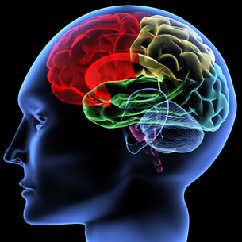
TMZ is a small lipophilic monofunctional DNA alkylating agent, commonly used to treat metastatic malignant melanomas as well as tumors of the central nervous system (CNS), such as Glioblastoma Multiforme (GBM). Shors’s group also showed evidence of TMZ’s selective affect on neurogenesis, and not glia generation. They proposed the reason for this observation to be the possible differences in DNA repair mechanisms between neural precursors and glia. This notion is further supported by previous reports indicating that unlike TMZ, chemotherapeutic agents that do not readily cross the blood brain barrier (BBB), lower hippocampal neurogenesis and give rise to abnormal dendritic morphology. Additionally, it has been shown that cells surviving radiation therapy tend to differentiate into glial cells rather than neurons.
While most cancer patient undergoing chemotherapy experience short-term memory loss and difficulty performing complex tasks, about 15% of patients experience long-lasting cognitive problems due to long-term chemotherapy treatment. Identifying the underlying cause of some of these cognitive deficits is a major step towards finding of alternative agents or modifying current ones to eliminate or alleviate these issues.

